**Install ROS robot control system with a virtual system**

Initially, we will need a Linux system to be able to install a ROS system on it, For the topic to be more practical for those whose original system is not Linux; We will install a virtual system first for the device and then install

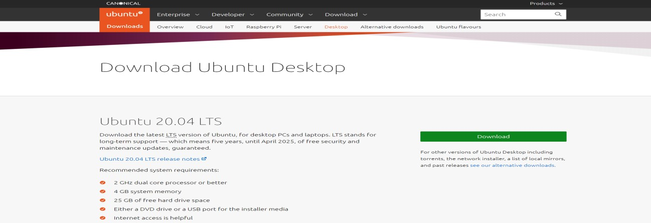

Download (Oracle VM VirtualBox) program, which is one of the free open-source programs for running virtual systems inside your system.

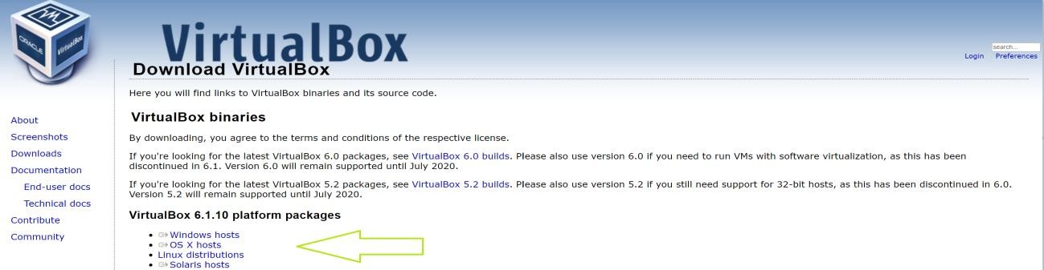

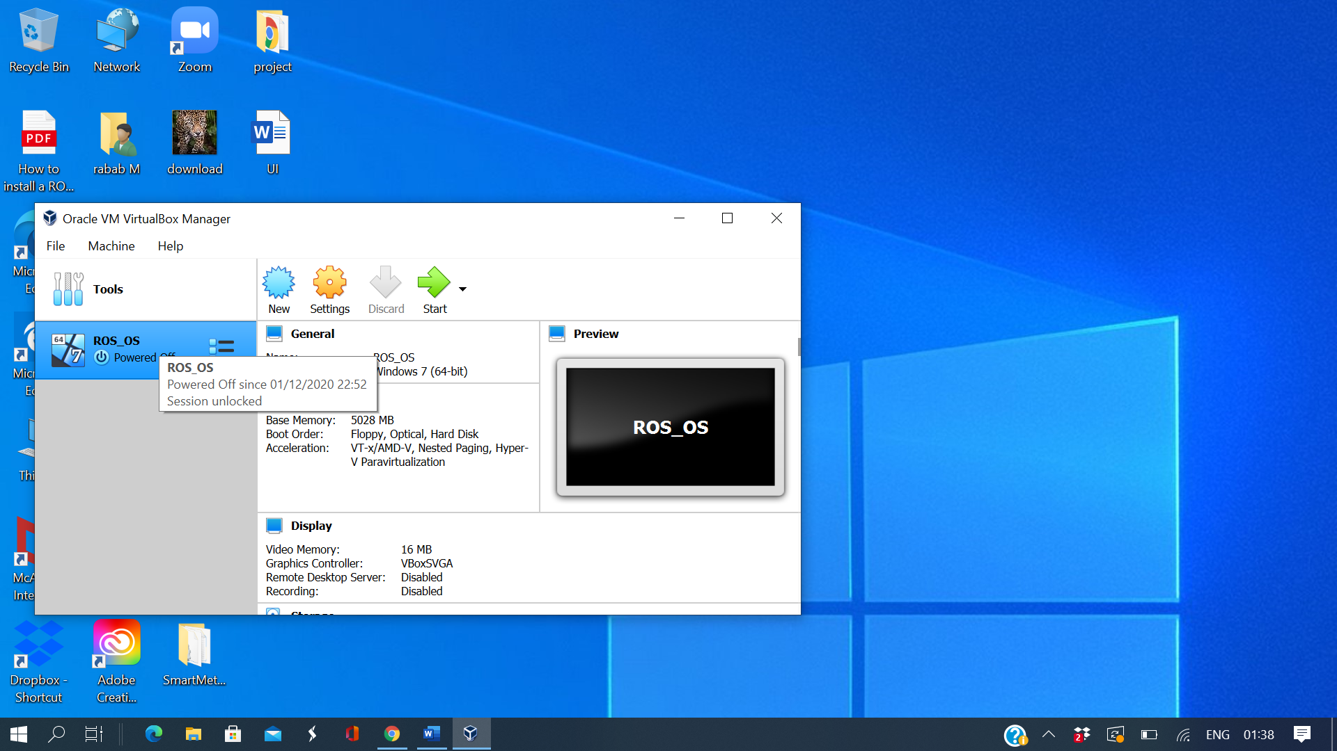

Preparing to install a system (Ubuntu)

We open the (VirtualBox) program and then go to (New) 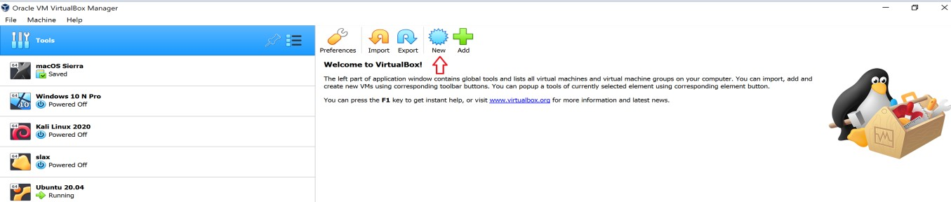

After completing the installation, you will see that you take a tour of options for the first use, it will look like a normal system with programs and others, but what we care about to install (ROS) is (Terminal)

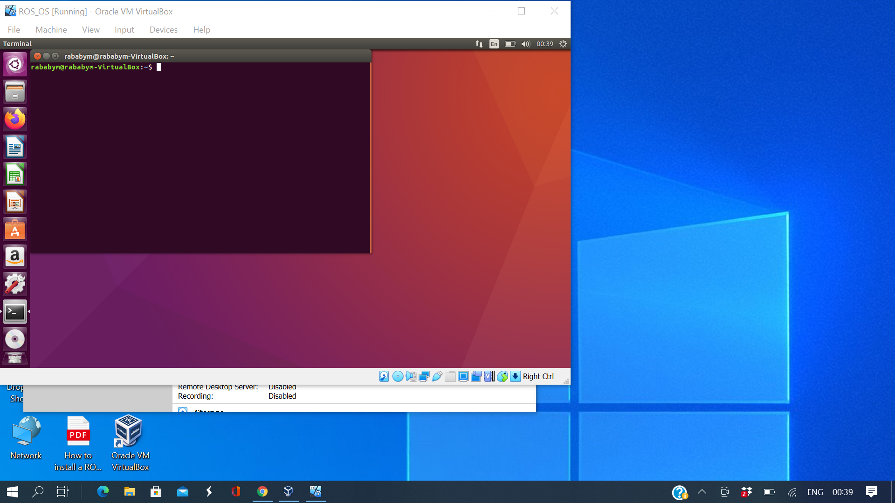

(ROS) system-installation by copy and paste commands to terminal

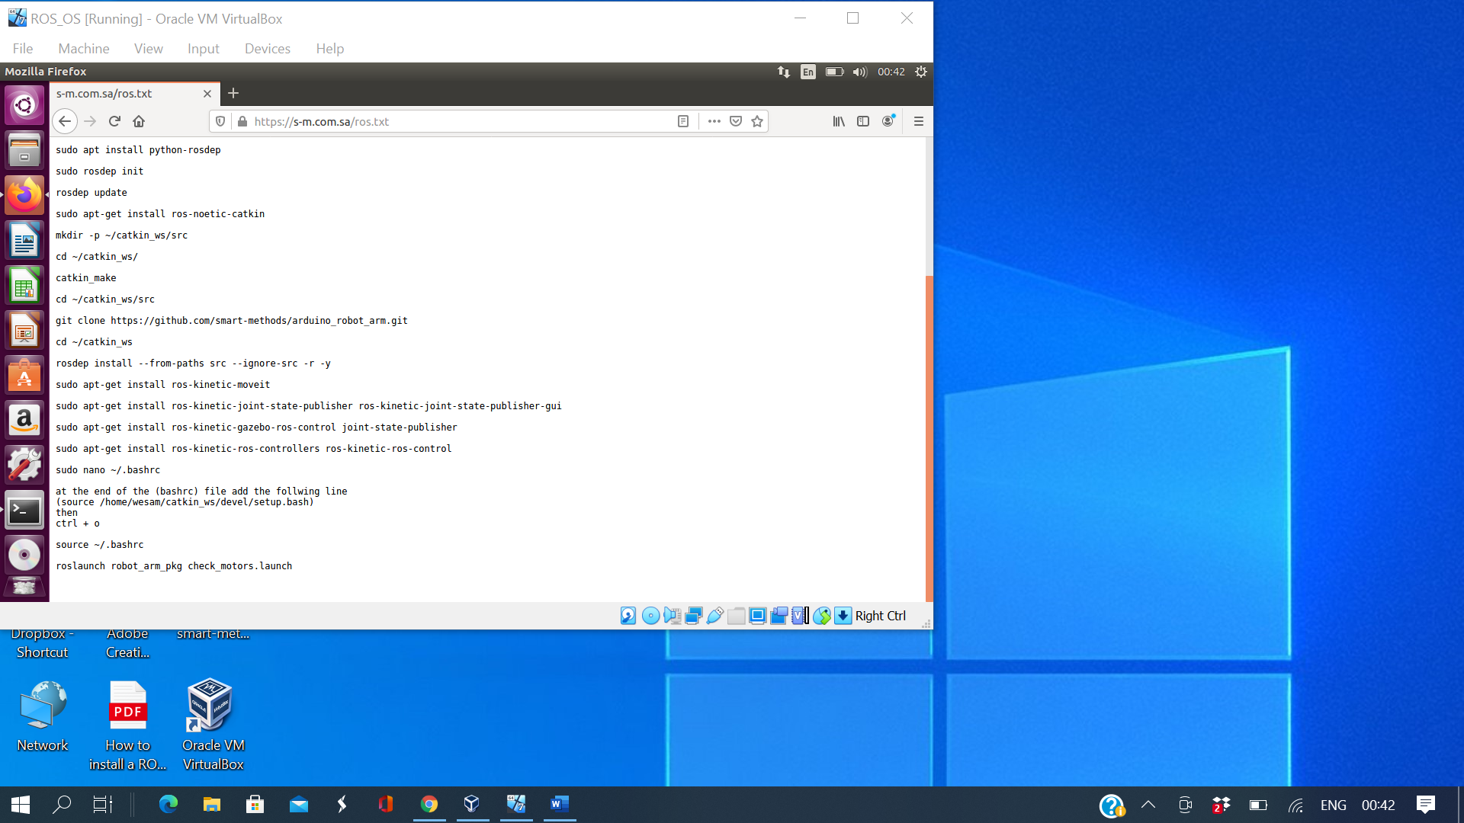

The installation is complete

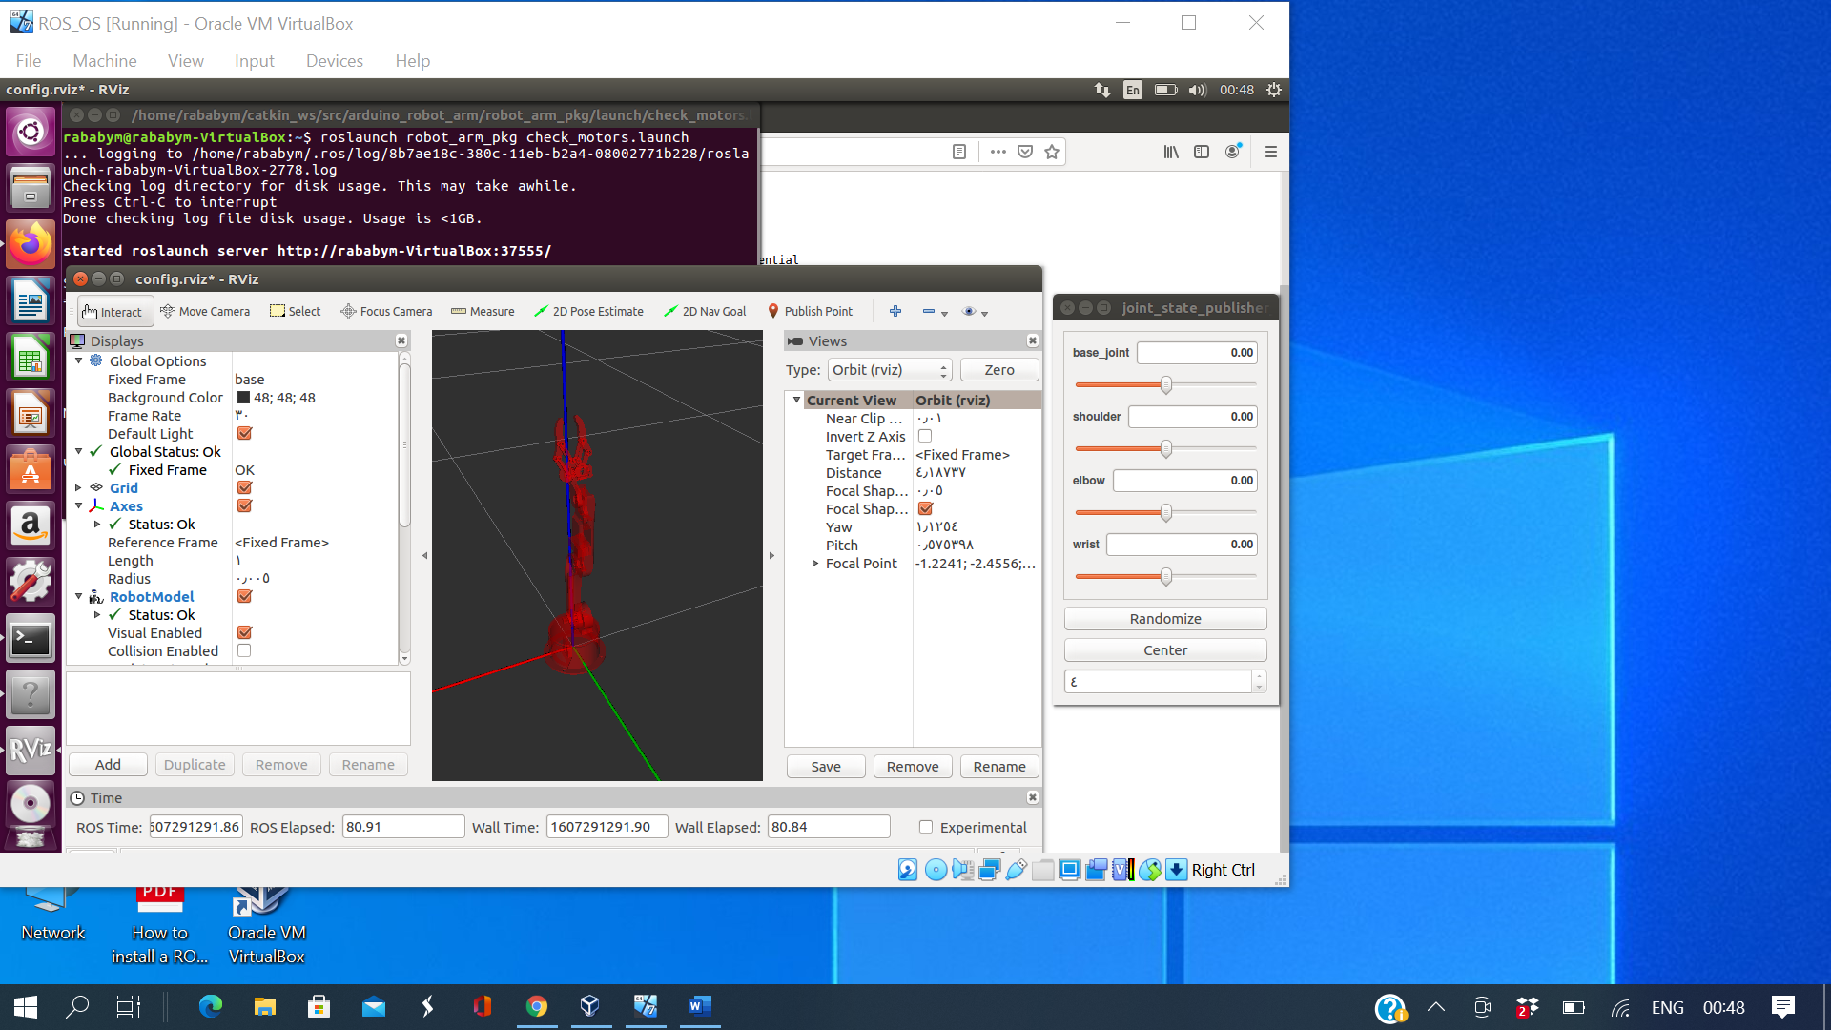

Arduino installation is complete

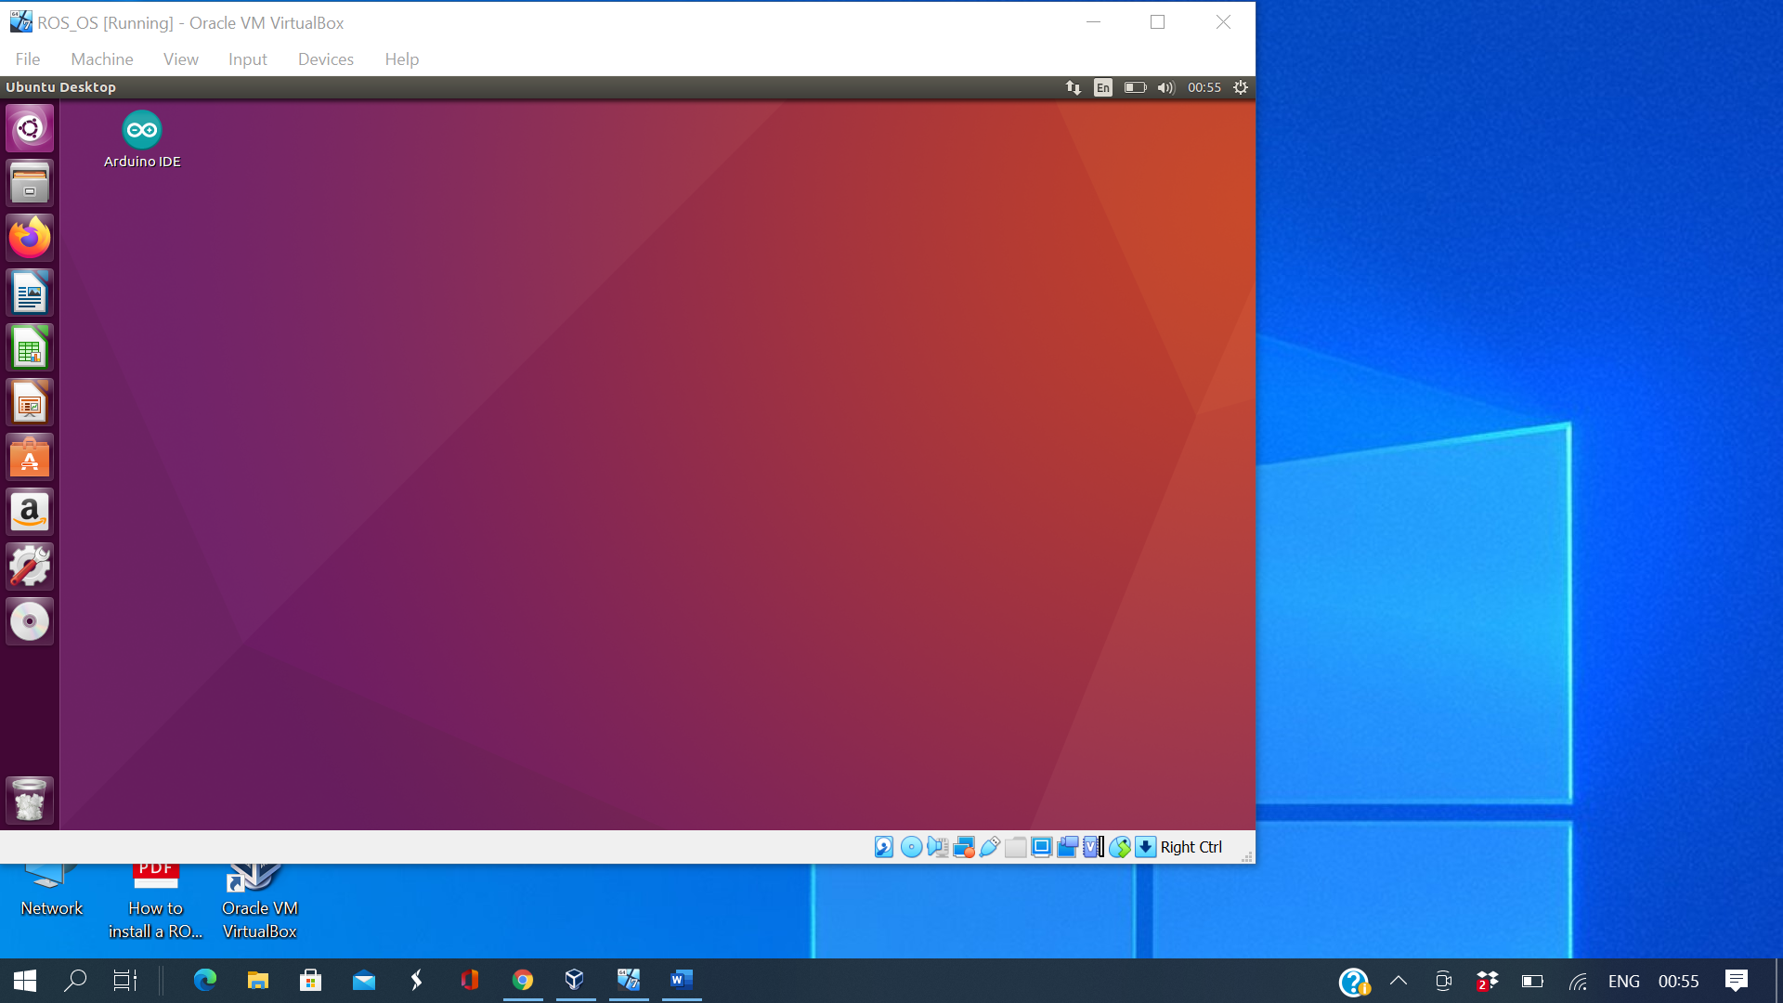

By : Rabab Mobaraki